Mark Wagner

SDEV300-7893 Lab5

Prof. Cooper

4/21/2019

Mr. Supervisor of IT Security,

For this security audit, I disassembled the basic login form and it’s subsequent pages that were used in the last week’s lab.

One thing I realized had to be done was removal of sessions between tests. I could not modify break- captured get or post requests while sessions kept the variables held. I was able to subvert requests to the page and modify the request, hence modifying the response in turn.

The best way to stop hackers from intercepting packets of responses sent to websites is to use SSL encryption and ensure that every page is an https page.

Alert: Web browser XSS protection not enabled, X Content…

Please note that before the tests there were 5 alerts of low to medium severity. One was a reflected XSS warning which was fixed by altering the response header with this:

Header set X-XSS-Protection "1; mode=block"

Alert: Incomplete or no-cache control on http header:

The next problem in order of Severity was that content could be sniffed by browsers that enable MIME Sniffing (sniffing packet data to determine content type in-lieu of metadata specifying type (jpg, pdf, etc). That was fixed by adding this to the headers:

Header set X-Content-Type-Options nosniff

Alert: Cookie no httpOnly header flag

OWASP A3 Threat – Release of sensitive information:

Finally, this was not part of my initial task for our company website but I thought it would help mitigate a low-level, low-priority threat which allowed third party javascript running on browsers to steal cookie information from the http response and potentially transmit it to a session jacker. This only allows the cookie to be given to http requests and not JS. It is mostly important for IE and Chrome users.

Header set Set-Cookie HttpOnly;Secure

With these vulnerabilities mitigated, all that remains are two false alerts indicating a sitemap present (for seo purposes) and a robot.txt thing that doesn’t matter for security purposes.

As far as basic scanning and scripting techniques, we are more secure as a result of these changes.

We are safe for now!

The following are screenshots of what occurred in chronological order with comment boxes detailing them inside.

Attached to this submission are the httpd.conf file, an html error report, and an access.log file.

Citation:

S. O., & Kumar, C. (2018, February 06). Secure cookie with HttpOnly and Secure flag in Apache. Retrieved from <https://geekflare.com/httponly-secure-cookie-apache/>

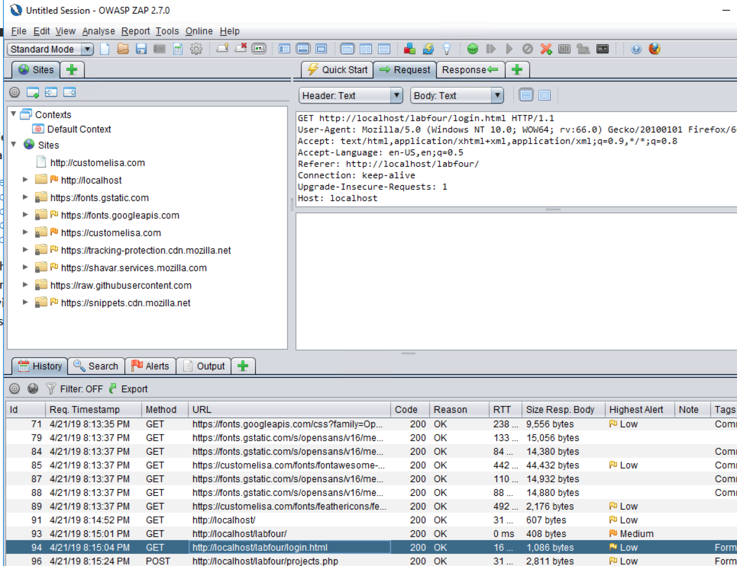

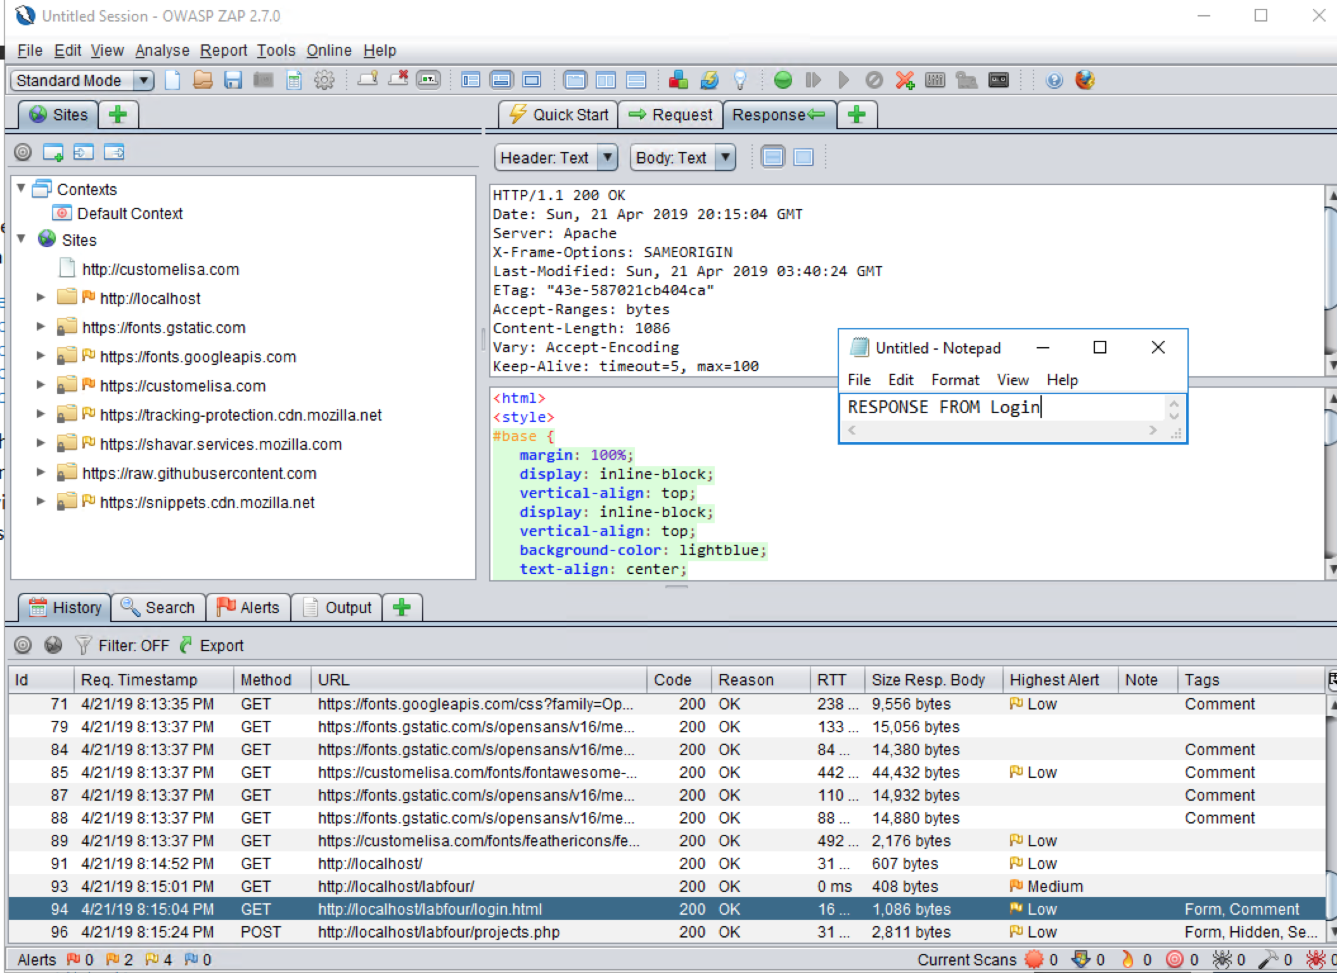

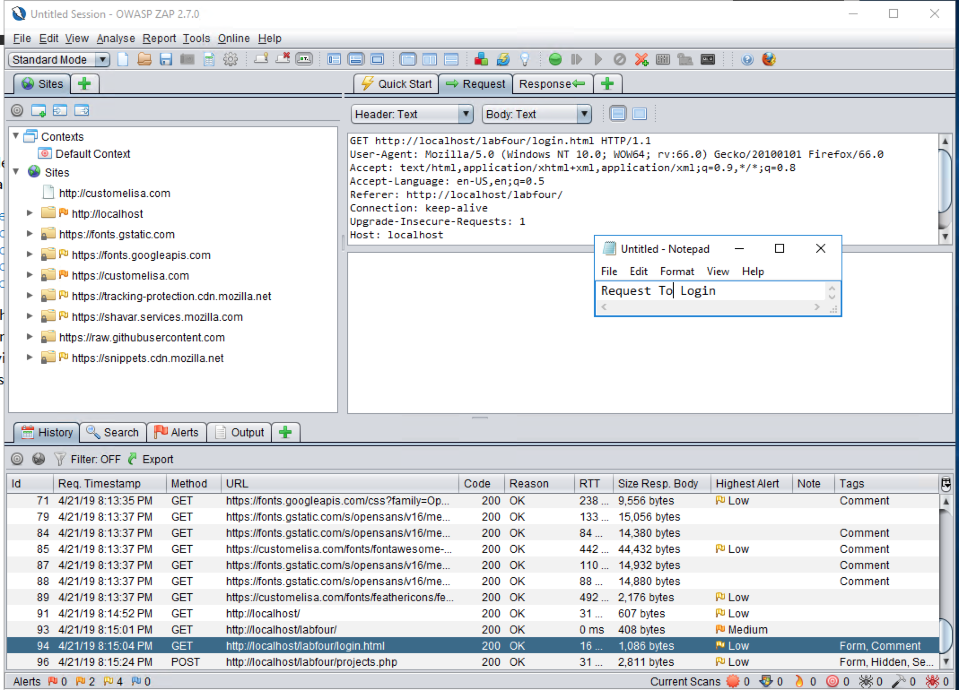

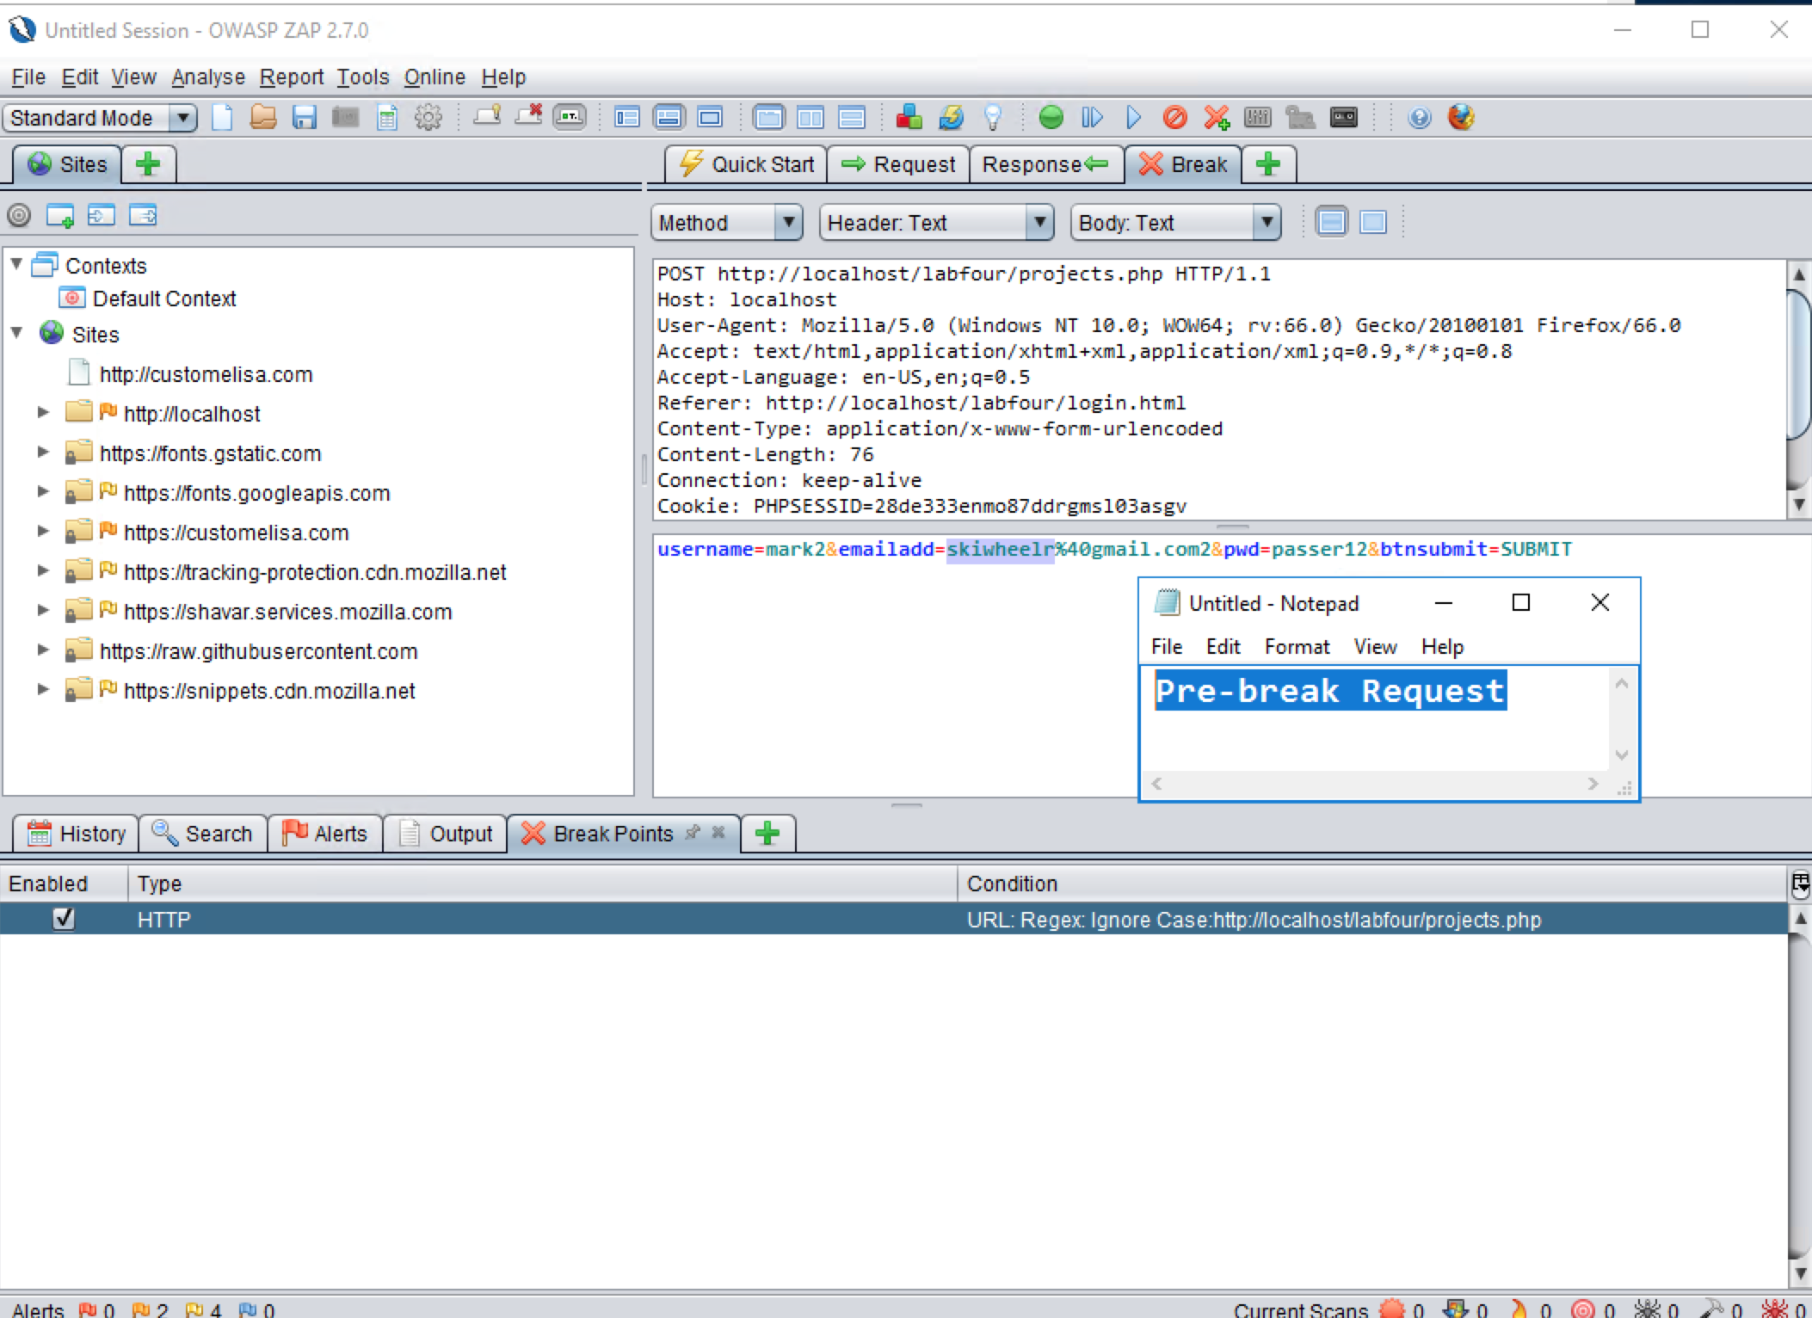

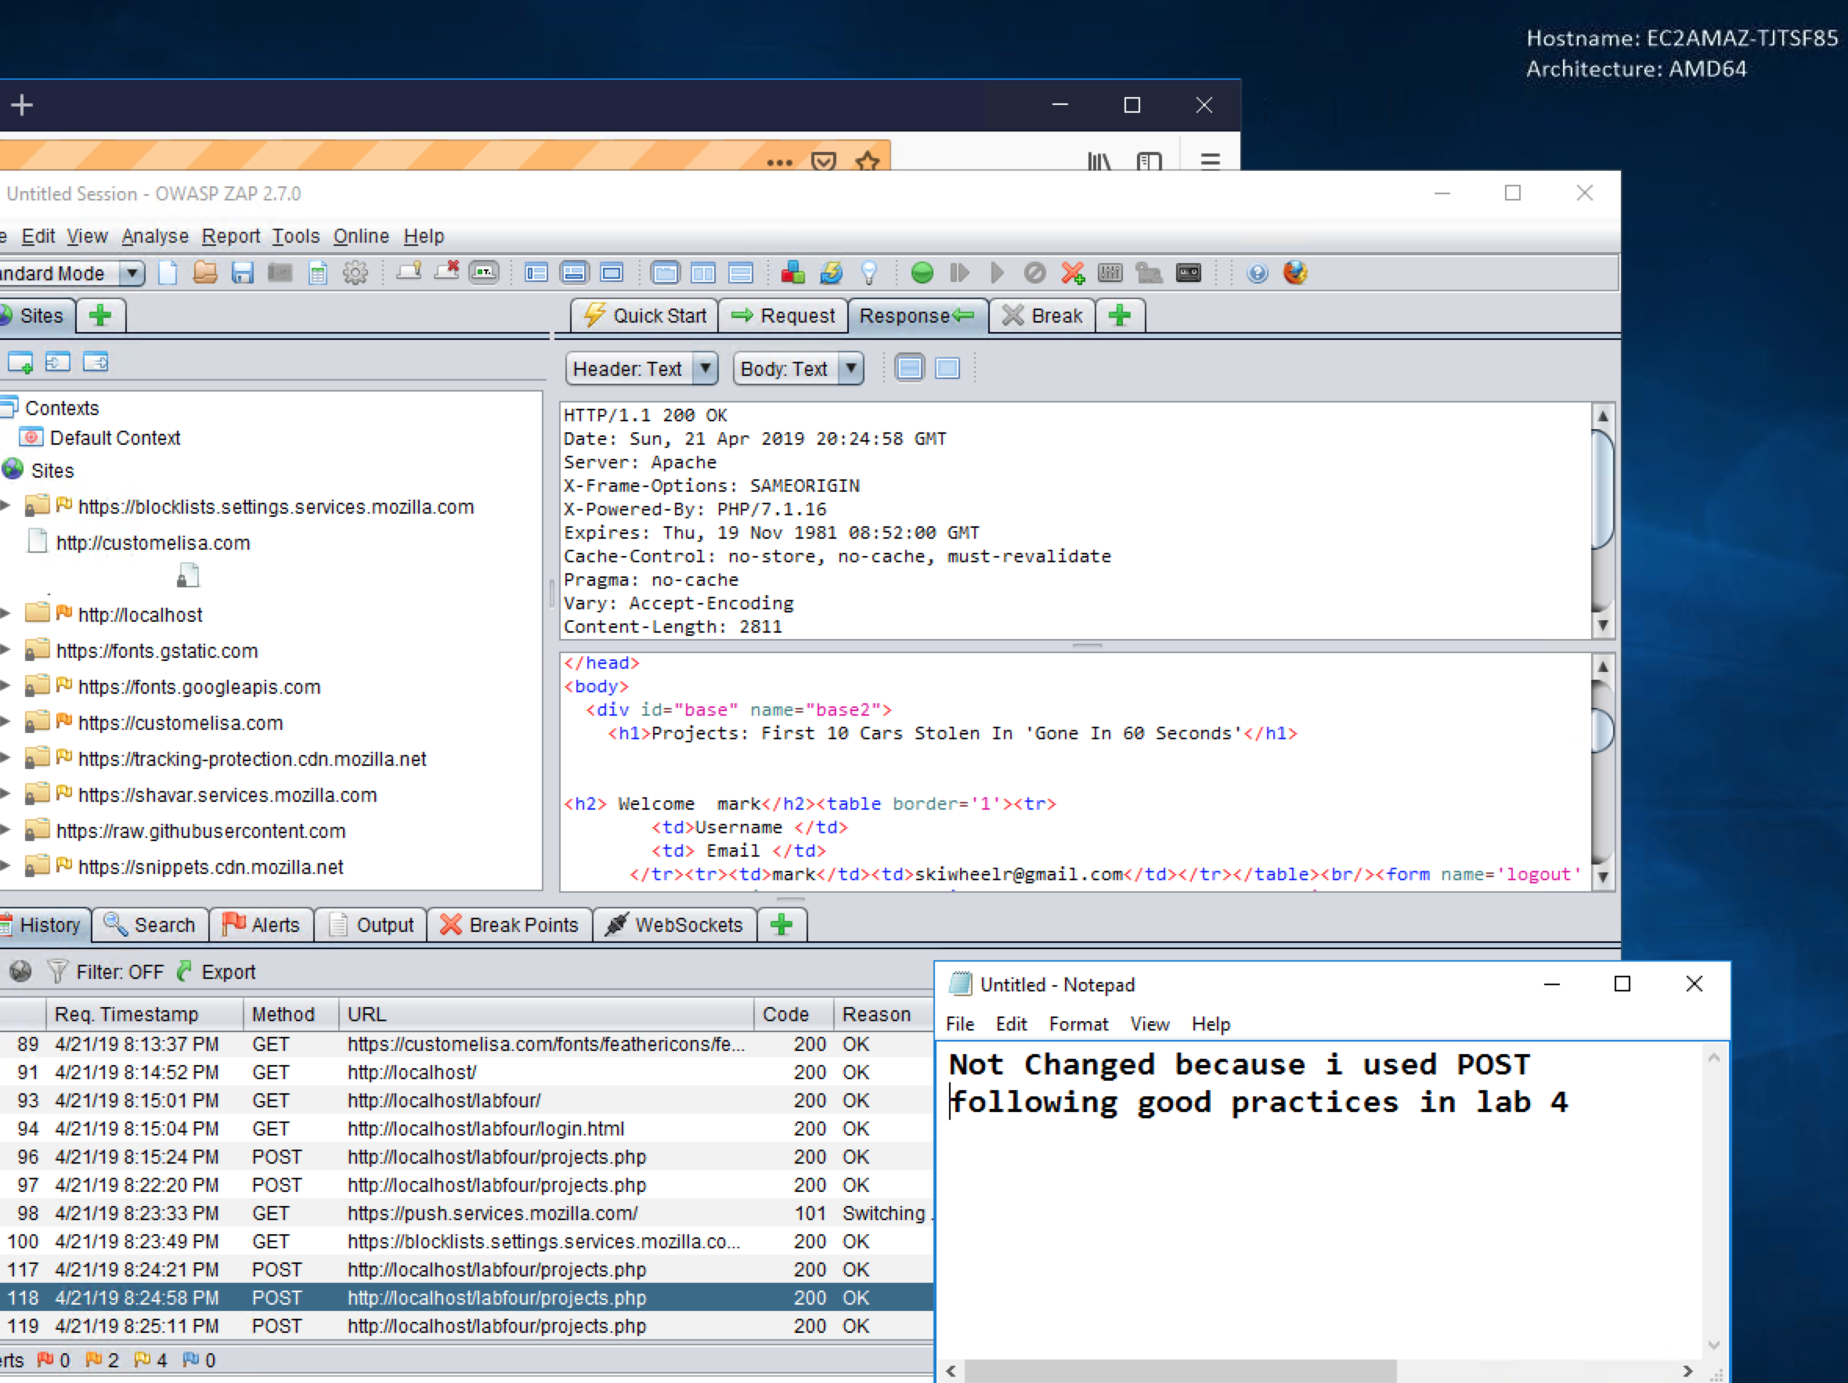

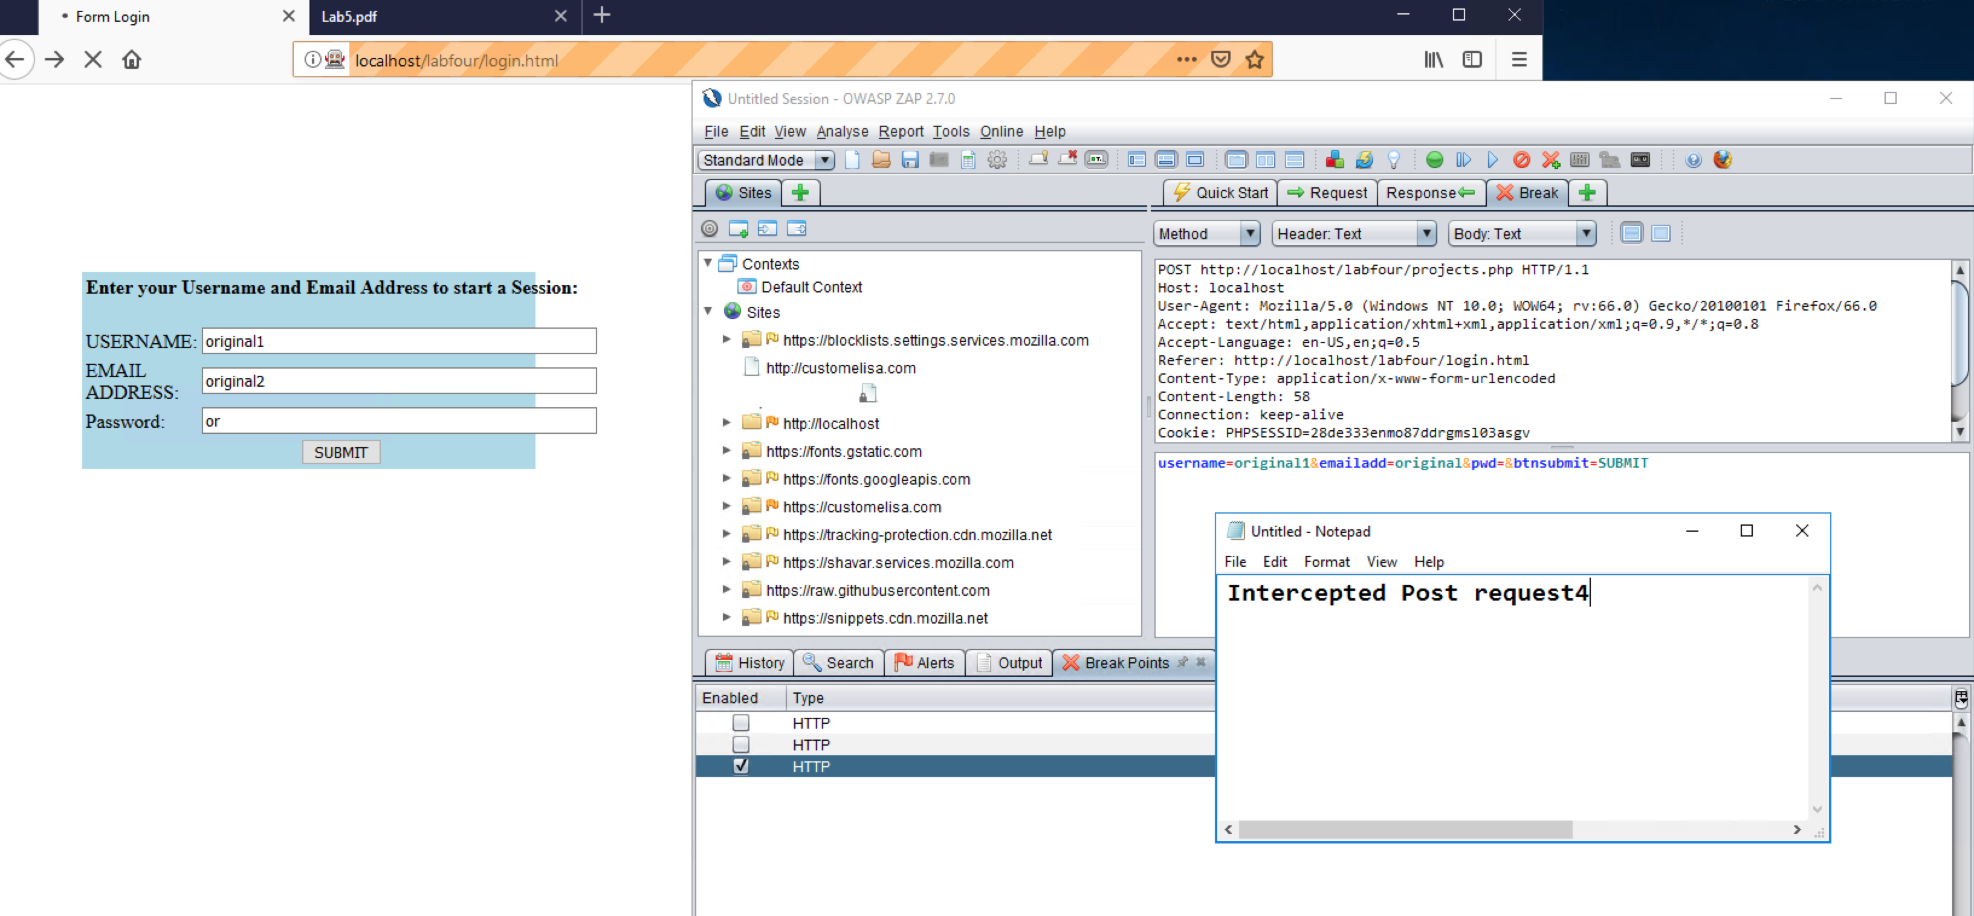

eff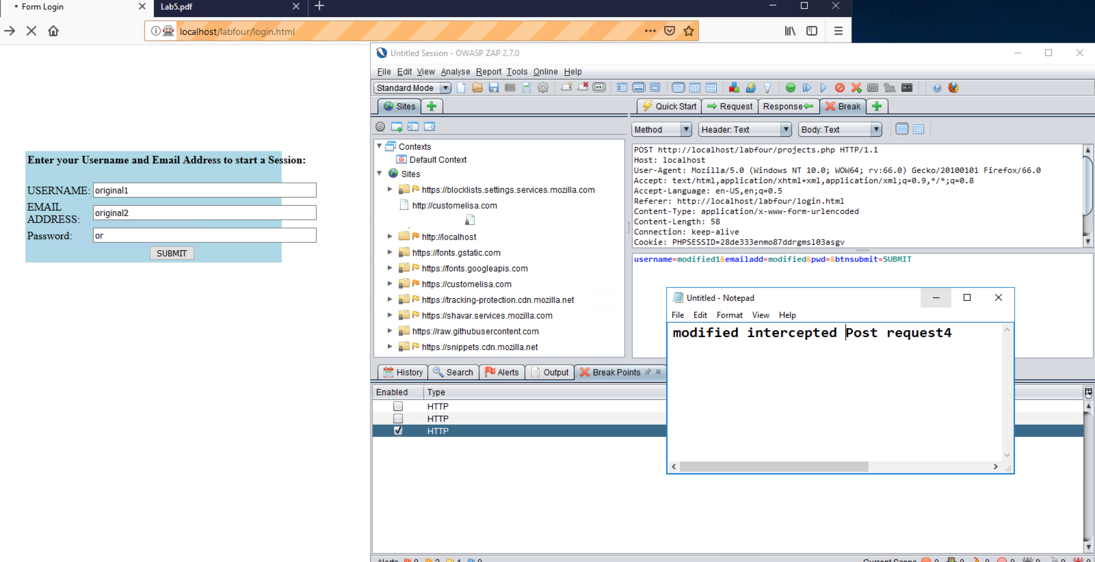

f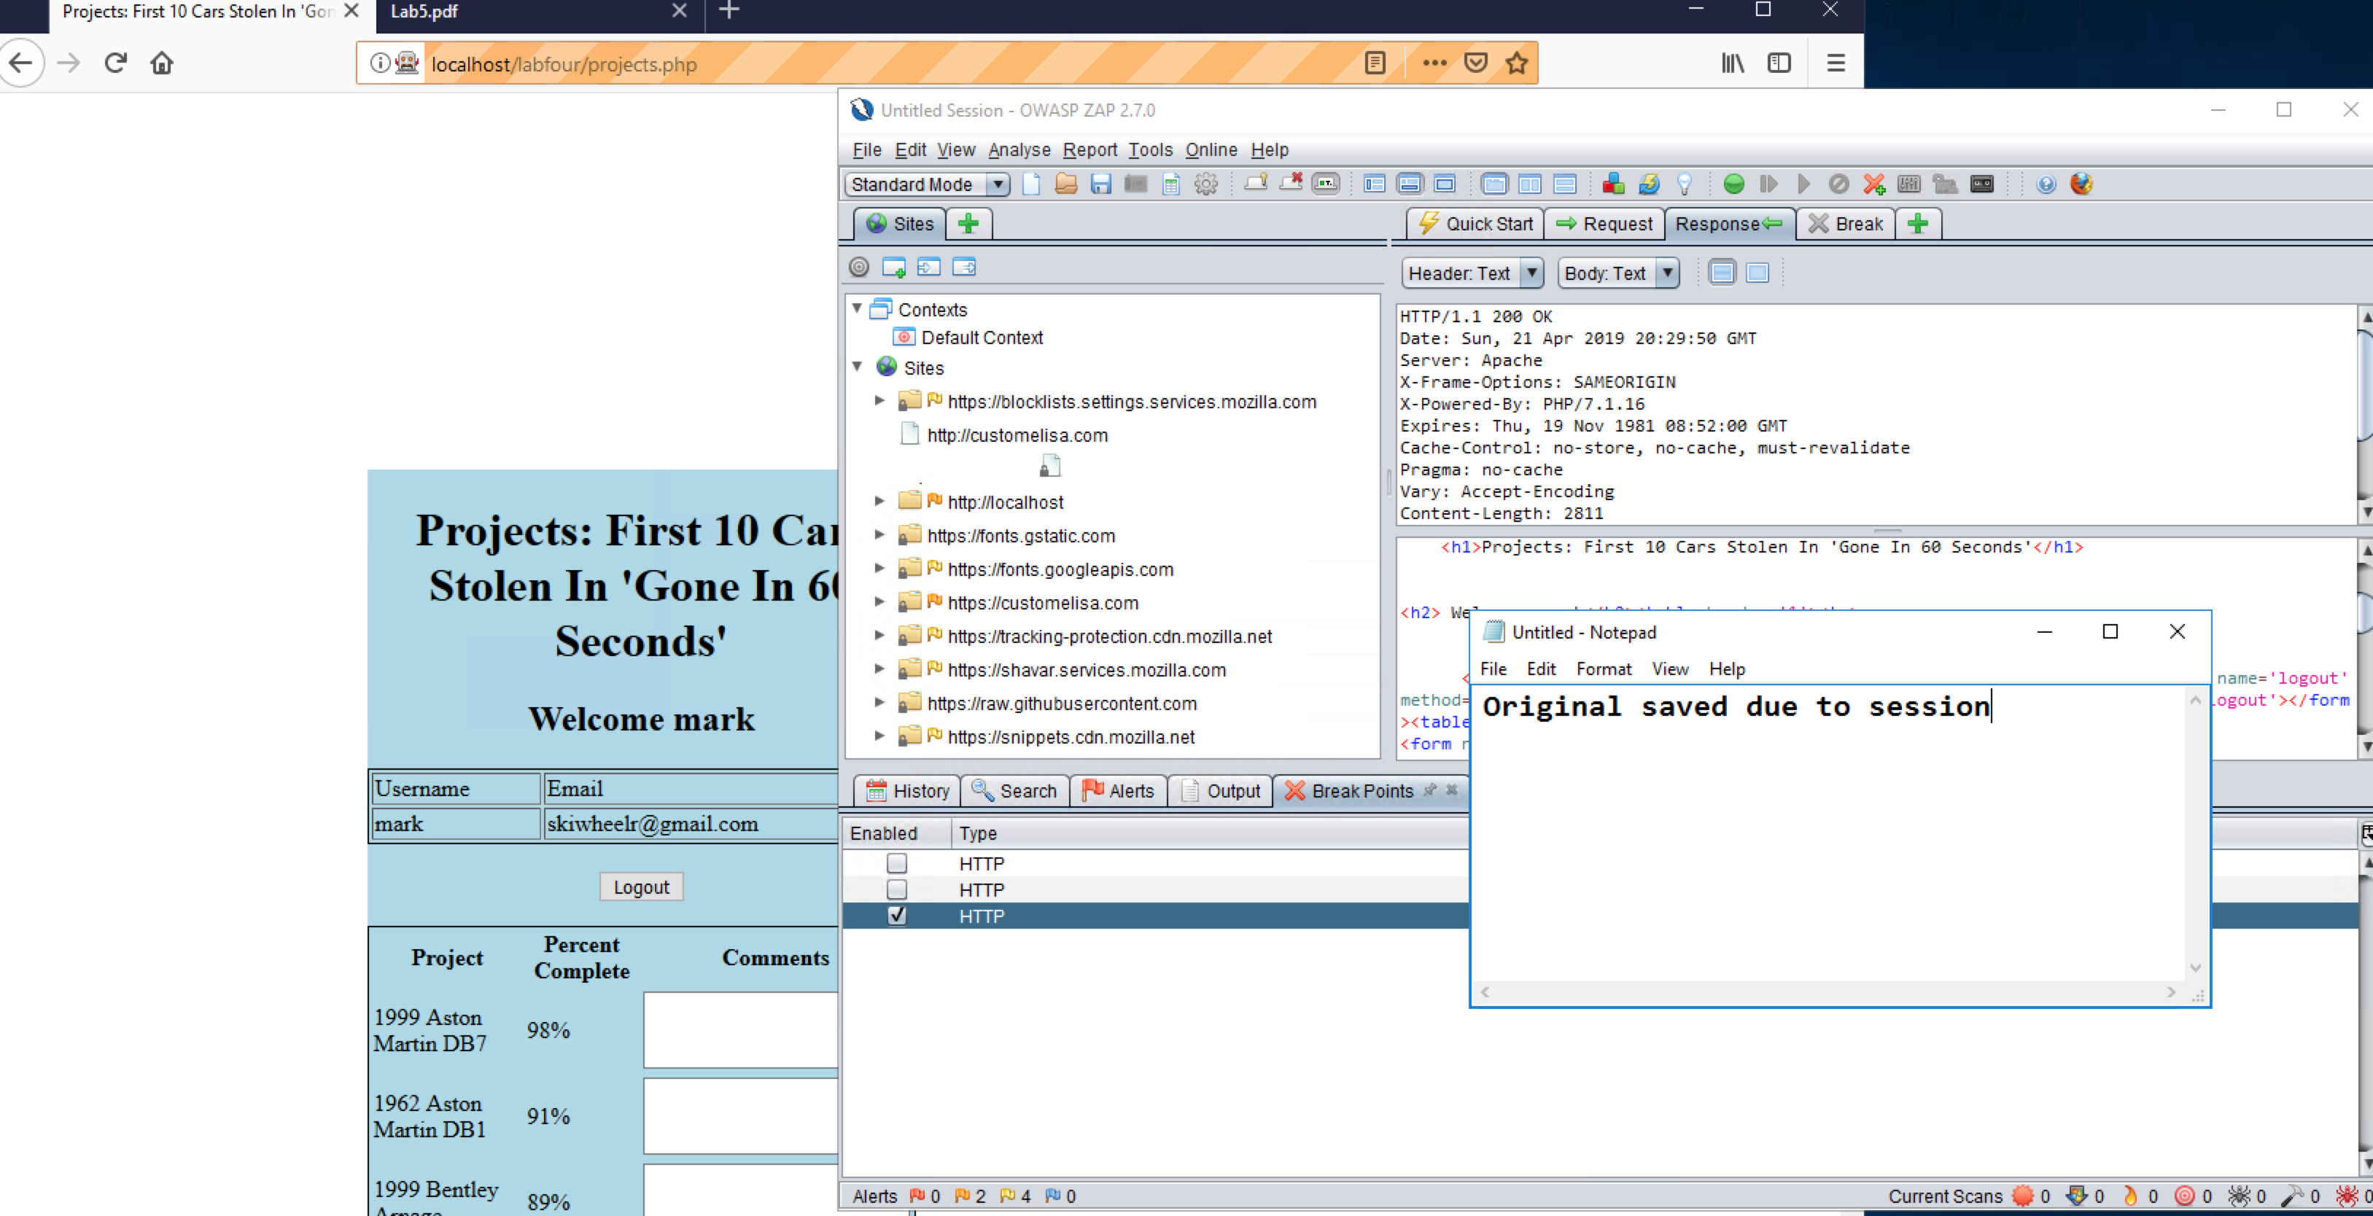

f